

**Alpine Canada Alpin**

**Coach Education**

**Operations Manual**

DRAFT – April 2017

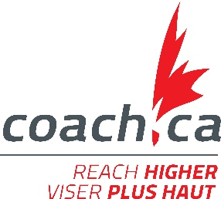

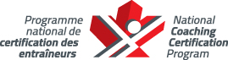



**The Collection, Use, and Disclosure of Personal Information**

The Coaching Association of Canada collects your NCCP qualifications and personal information and shares it with all NCCP partners according to the privacy policy detailed at [www.coach.ca](http://www.coach.ca). By participating in the NCCP you are providing consent for your information to be gathered and shared as detailed in the privacy policy. If you have any questions or would like to abstain from participating in the NCCP please contact [coach@coach.ca](mailto:coach@coach.ca).

Table of Contents

Introduction 1

1 Alpine Canada Alpin and NCCP 2

1.1 ACA Strategic Plan 2

1.2 Partners in Coach Education 3

1.3 Participant and Coach Development Model 5

1.4 Long-Term Athlete Development 6

2 The NCCP Model 7

2.1 NCCP Streams & Contexts 8

2.2 Alpine NCCP Contexts 9

2.3 Training vs. Certification 9

2.4 Alpine Coach Pathways 11

2.5 Workshops and Modules 17

3 Coach Evaluation and Certification 20

3.1 Objectives 20

3.2 Principles of Evaluation in the NCCP 20

3.3 Outcomes, Criteria, and Evidence 20

3.4 Evaluating Coaches in the NCCP 22

3.5 Certification Standard 22

3.6 NCCP Database (the Locker) 23

3.7 Administration and Logistics of Evaluation 23

3.8 Equivalency and Recognition of Coaching Competence 23

4 Coach Developers 24

4.1 Identification and Selection of Coach Developers 25

4.2 Learning Facilitator 25

4.3 Coach Evaluator 27

4.4 Master Coach Developer 30

4.5 Communication 33

4.6 Responsibilities and Planning 35

4.7 Fee Structure and Payment 36

4.8 Professional Development and Licensing 37

4.9 Quality Control 38

4.10 Minimum Age Restrictions 38

5 Tools 39

5.1 NCCP Code of Ethics 39

5.2 Alpine Coach Developer Code of Conduct 41

Introduction

Purpose of this Document

The National Coaching Certification Program (NCCP), launched in 1974 and delivered in partnership with the government of Canada, provincial/territorial governments, and national/provincial/territorial sport organizations, gives coaches the confidence to succeed.

The CAC works with over 65 different National Sport Organizations, including ACA, across Canada in the development of sport-specific NCCP training. Currently, there are over 850 workshops available at every level of sport – from 3-hour online introductory workshops for beginner coaches, to weekend workshops for intermediate coaches, to intensive two-year training programs for advanced coaches.

This *ACA – NCCP Operations Manual* contains guidelines and procedures for successful implementation of the NCCP. It is not intended to replace the *NCCP Policies and Implementation Standards*, nor does it serve as development guidelines.

Version Control

The following outlines the version history of this document, and identifies any notable changes.

|  |  |
| --- | --- |
| **Revision Date** | **Revisions** |
| 2017/05/01 | Original draft document publication in English |
|  |  |
|  |  |

# Alpine Canada Alpin and NCCP

## ACA Strategic Plan

ACA’s [strategic plan](http://www.alpinecanada.org/sites/default/files/attachments/aca_strategicplan_2015-18_en.pdf) is available on the ACA web site. The current version referenced from this document is the 2015-2018 version.

Four main strategic priorities for this period are:

1. evolve the ACA financial and organizational model.
2. deepen the high performance athletic pipeline
3. develop coaching excellence at all levels in the sport
4. align the ACA/PTSO relationship to work better together

Within the ACA coaching education department, two main goals that contribute to the above priorities are:

1. create a culture of learning that produces more certified expert coaches at all levels.
2. facilitate the hiring of Canadian high performance coaches in leadership roles in all ACA National Team programs.

## Partners in Coach Education

The CAC, the provincial/territorial NCCP delivery agencies, the National Sport Organizations (NSOs), and the federal-provincial/territorial governments are individually and collectively responsible to:

Ensure that the NCCP and other coaching and sport leader development programs contribute to a safe and ethical sport experience in all contexts of participation;

Ensure that the programs integrate into the Canadian Sport For Life framework and follow the principles of Long-Term Athlete Development (LTAD);

Ensure that coaching and sport leader development programs are available in both French and English;

Use best efforts to make the program accessible to all, including traditionally underrepresented and/or marginalized populations as referenced in the Canadian Sport Policy and the Federal-Provincial/Territorial Priorities for Collaborative Action;

Endorse the value of competent coaches and support, along with other stakeholders, higher standards of coaching competencies and working conditions/environments for coaches;

Actively participate in the resolution of any differences that put the integrity and continuity of the NCCP at risk.

### Coaching Association of Canada (CAC)

The Coaching Association of Canada unites stakeholders and partners in its commitment to raising the skills and stature of coaches, and ultimately expanding their reach and influence. Through its programs, the CAC empowers coaches with knowledge and skills, promotes ethics, fosters positive attitudes, builds competence, and increases the credibility and recognition of coaches.

### Provincial/Territorial Coaching Representatives (PTCRs)

The Provincial/Territorial Coaching Representatives provide leadership, development, and support in delivering the NCCP.

Alberta: Alberta Sport Connection

British Columbia: ViaSport BC

Manitoba: Coaching Manitoba

New Brunswick: Coach NB

Newfoundland and Labrador: Sport Newfoundland and Labrador

Northwest Territories: Sport North Federation

Nova Scotia: Department of Health and Wellness, Active Living Branch

Nunavut: Sport and Recreation Division

Ontario: Coaches Association of Ontario

Prince Edward Island: Sport PEI

Quebec: SportsQuébec

Saskatchewan: Coaches Association of Saskatchewan

Yukon: Sport and Recreation, Department of Community Services, Government of Yukon

### National Sport Organization (NSO)

Alpine Canada Alpin provides leadership and works with its PTSOs to develop and deliver all aspects of NCCP coaching education programs and services for Alpine Ski racing programs at all levels in Canada.

### Provincial/Territorial Sport Organizations (PTSOs)

BC Alpine

Alberta Alpine

Alpine Saskatchewan

Manitoba Alpine

Alpine Ontario Alpin

Ski Québec Alpin

New Brunswick Alpine

Alpine Ski Nova Scotia

PEI Alpine Ski Association

Alpine Ski Newfoundland and Labrador

Alpine Yukon

## Participant and Coach Development Model

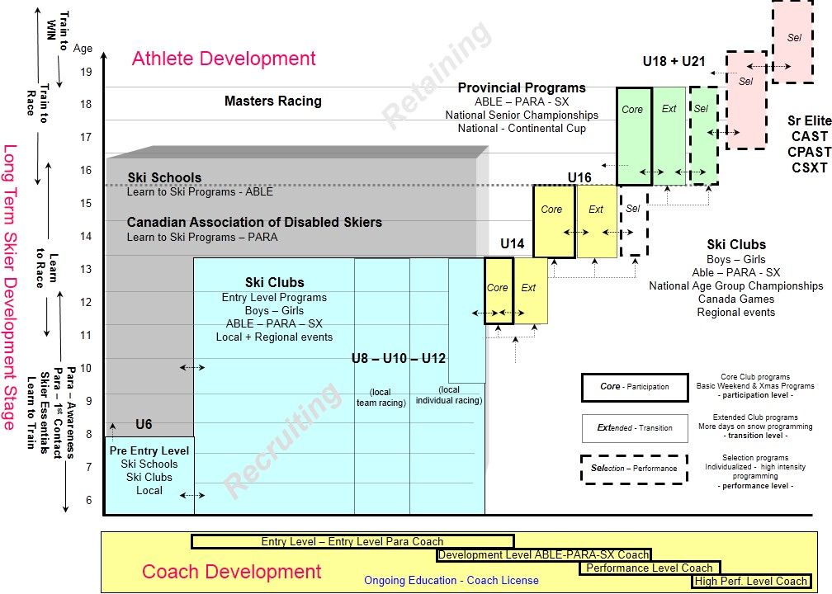

## Long-Term Athlete Development

### AIM 2 WIN Long Term Skier Development Model

The AIM 2 WIN long term skier development model forms the basis for athlete progress and coach training for all alpine ski racing programs in Canada.

The graphic below represents the alpine specific stages of athlete progression upon which the coach education and training program is developed.

[Detailed AIM 2 WIN information](http://www.alpinecanada.org/alpine/development-alpine) is available on the ACA web site.

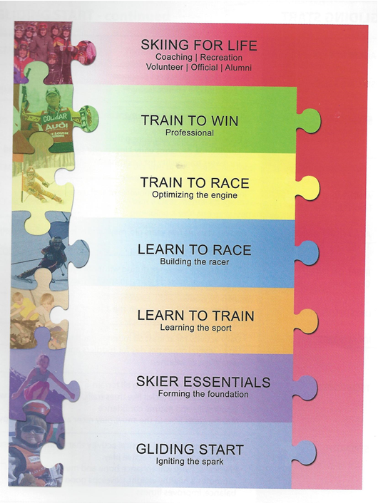

The chart below provides an overview of how the Alpine coaching program links to specific stages of athlete development.

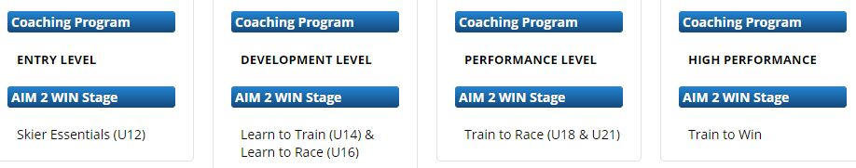

For para-alpine programs, PARA-AIM 2 WIN guidelines identify both recreational and competitive streams for skiers with a disability based on "age of experience" with disabilities, either congenital or newly acquired disabilities.

# The NCCP Model

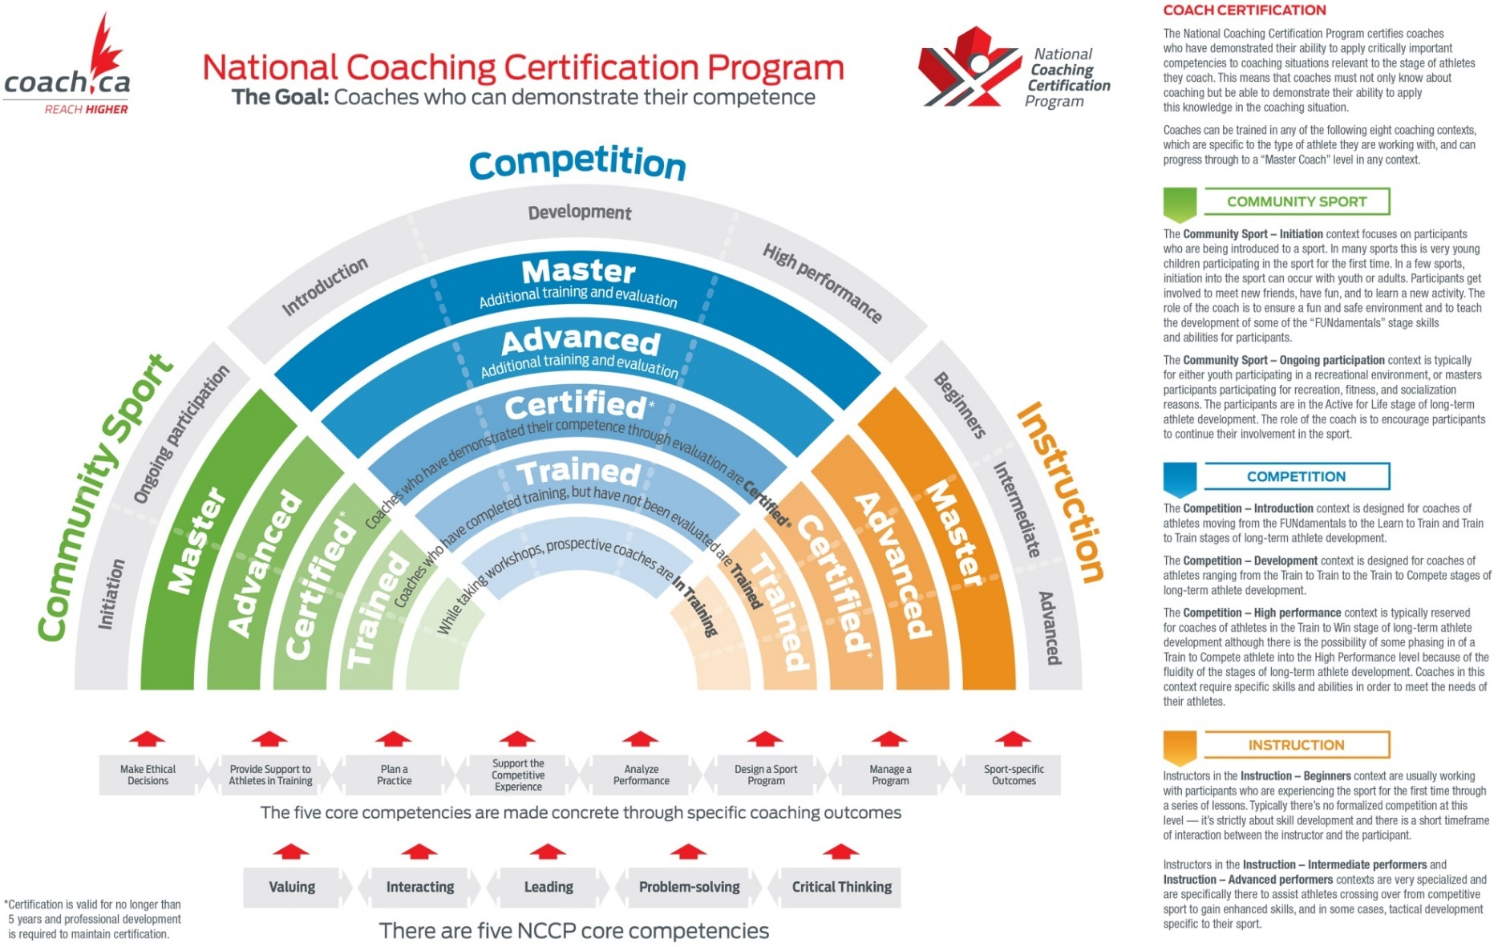









## NCCP Streams & Contexts

* + 1. **Community Sport http://www.coach.ca/files/Coach_Type_Comm_Coach_ENG.jpg**

You may already coach at the community level or you’re thinking about coaching. Often, you’re a parent whose child is involved in sport, or a volunteer who works with participants of all ages that are new to a sport.

There are two levels of workshops for community sport coaches: Initiation (or introduction) and Ongoing participation.

* The **Community Sport – Initiation** context focuses on participants who are being introduced to a sport. In many sports this is very young children participating in the sport for the first time. In a few sports, initiation into the sport can occur with youth or adults. Participants get involved to meet new friends, have fun, and to learn a new activity. The role of the coach is to ensure a fun and safe environment and to teach the development of some of the “FUNdamentals” stage skills and abilities for participants.
* The **Community Sport – Ongoing participation** context is typically for either youth participating in a recreational environment, or masters participants participating for recreation, fitness, and socialization reasons. The participants are in the Active for Life stage of long-term athlete development. The role of the coach is to encourage participants to continue their involvement in the sport.

For more information please visit: <http://www.coach.ca/community-coaches-s15434>.

* + 1. **Competition http://www.coach.ca/files/Coach_Type_Comp_Coach_ENG.jpg**

Coaches in the Competition stream usually have previous coaching experience or are former athletes in the sport. They tend to work with athletes over the long term to improve performance, often in preparation for provincial, national, and international competitions.

There are three levels of workshops for competition coaches that reflect the stages of athlete development: Introduction, Development, and High performance.

* The **Competition – Introduction** context is designed for coaches of athletes moving from the FUNdamentals to the Learn to Train and Train to Train stages of long-term athlete development.
* The **Competition – Development** context is designed for coaches of athletes ranging from the Train to Train to the Train to Compete stages of long-term athlete development.
* The **Competition – High performance** context is typically reserved coaches of athletes in the Train to Win stage of long-term athlete development although there is the possibility of some phasing in of a Train to Compete athlete into the High Performance level because of the fluidity of the stages of long-term athlete development. Coaches in this stream require specific skills and abilities in order to meet the needs of their athletes.

For more information please visit: <http://www.coach.ca/competitive-coaches-s15435>.

* + 1. **Instruction http://www.coach.ca/files/Coach_Type_Instr_Coach_ENG.jpg**

Instructors in the Instruction stream must have sport-specific skills and training, whether at the beginner or advanced skill levels. Many are former participants in the sport.

The Instruction stream has three different levels of workshops: Beginners, Intermediate performers, and Advanced performers.

* Instructors in the **Instruction – Beginners** context are usually working with participants who are experiencing the sport for the first time through a series of lessons. Typically there’s no formalized competition at this level – it’s strictly about skill development and there is a short timeframe of interaction between the instructor and the participant.
* Instructors in the **Instruction – Intermediate performers** and **Instruction – Advanced** **performers** contexts are very specialized and are specifically there to assist athletes crossing over from competitive sport to gain enhanced skills, and in some cases, tactical development specific to their sport.

For more information please visit: <http://www.coach.ca/instructors-s15436>.

For more information please visit: <http://www.coach.ca/where-do-i-fit--s15433>.

## Alpine NCCP Contexts

The NCCP model identifies three streams and eight different contexts that generally describe the environments where coaches practice.

ACA NCCP programs fit into the Instructor stream and competition stream as shown in the preceding NCCP Model graphic and the outline below.

Community Sport Stream

* 1. Initiation
  2. Ongoing Participation

Instructor Stream

* 1. Beginners - **Entry Level Alpine and Para-alpine**
  2. Intermediate
  3. Advance

Competition Stream

* 1. Introduction - **Development Level Alpine and Para-alpine**
  2. Development - **Performance Level Alpine**
  3. High Performance - **High Performance Level Alpine**

## Training vs. Certification

The NCCP model distinguishes between training and certification. Coaches can participate in training opportunities to acquire or refine the skills and knowledge required for a particular coaching context and be considered “trained”.

To become “certified” in a coaching context, coaches must be evaluated on their demonstrated ability to perform within that context in areas such as program design, practice planning, performance analysis, program management, ethical coaching, support to participants during training, and support to participants in competition.

Certified coaches enjoy the credibility of the sporting community and of the athletes they coach because they have been observed and evaluated “doing” what is required of them as a competent coach in their sport. They are recognized as meeting or exceeding the high standards embraced by more than 65 national sport organizations in Canada. Fostering confidence at all levels of sport, certification is a benefit shared by parents, athletes, sport organizations, and our communities.

Alpine coaches are described as follows:

**Trained**– when they have completed core training for a context;

**Certified**– when they have completed core evaluation requirements for a context.

**Certified Advanced** - when they have completed all training and evaluation requirements for a context

For more information, please visit:

NCCP: <http://www.coach.ca/trained-vs-certified-s16468>

ALPINE: <http://www.canskicoach.org/en/certification-programs/structure-progression>

## Alpine Coach Pathways

### Entry Level - Alpine

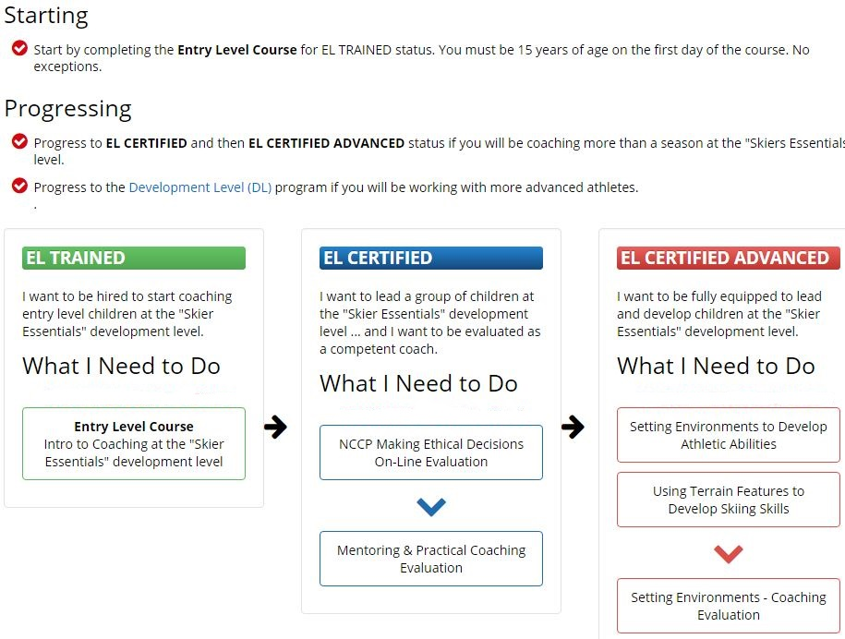

### Entry Level - Para-Alpine

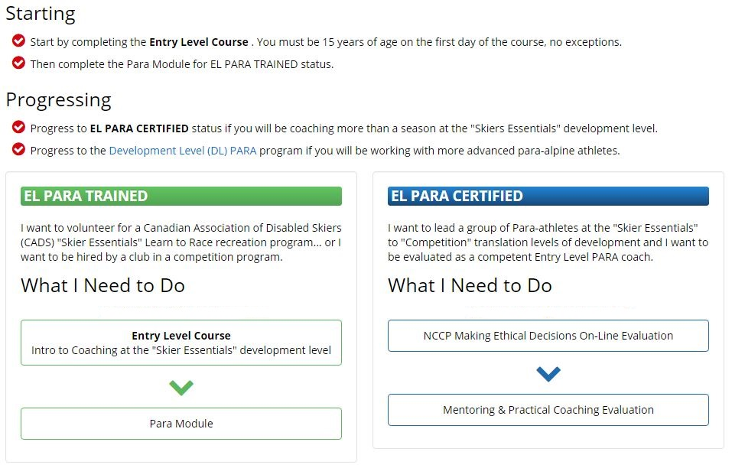

### Development Level - Alpine

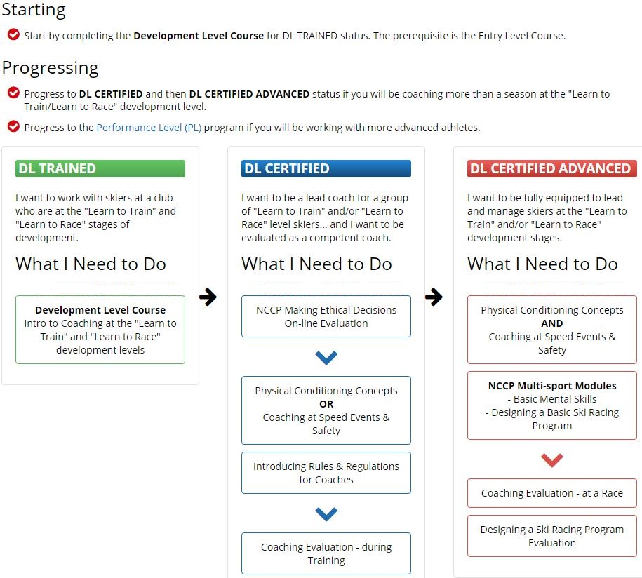

### Development Level - Para-Alpine

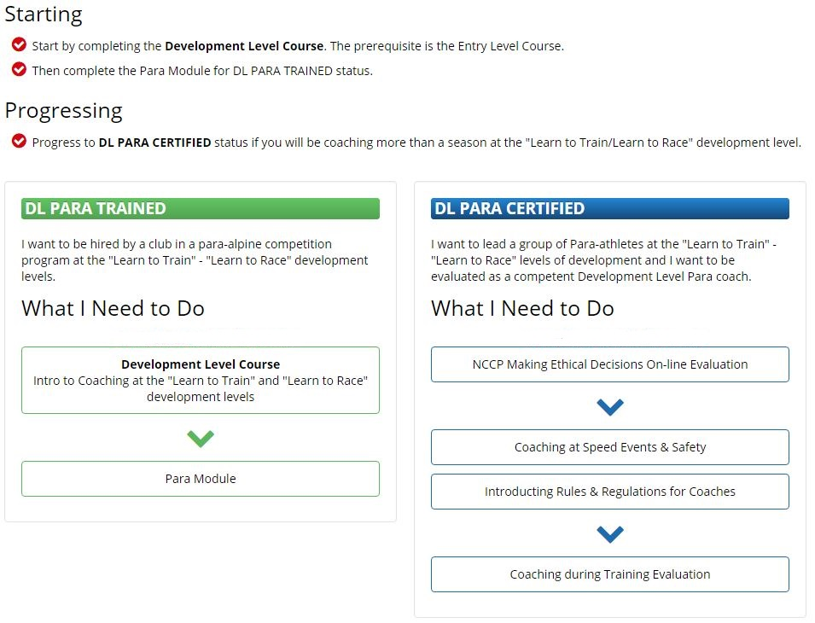

### Performance Level - Alpine

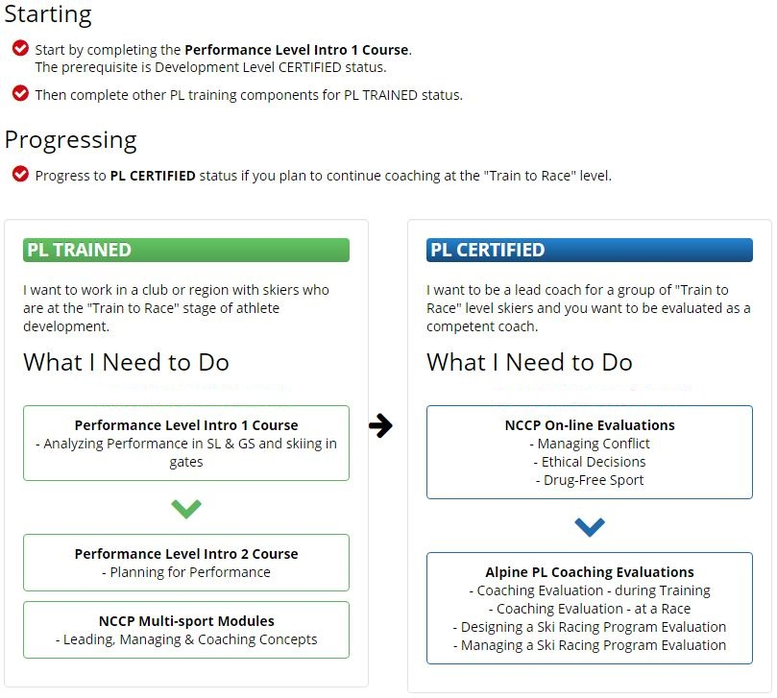

### High Performance Level

High performance coaches work with athletes on provincial and national teams who are at the "Train to Race" and "Train to Win" stages of development in Alpine Canada's AIM 2 WIN/PARA-AIM 2 WIN long term skier development module.

Coaches in this context are career professionals.

**Alpine Level 4 Program Discontinued**

The NCCP Level 4/5 program was discontinued by the Coaching Association of Canada on **December 31, 2015**. The Alpine Level 4 program was discontinued by ACA-CSCF on **September 30, 2016**.

**New Performance Level (PL) Advanced Gradation**

The Alpine Level 4 program will be replaced by a new Performance Level CERTIFIED ADVANCED certification status. This gradation will be added to the Performance Level coach pathway following TRAINED and CERTIFIED statuses.

The Advanced Coaching Diploma, offered through Canadian Sport Institutes (CSI) across the country, along with Alpine specific coach evaluation, will form the basis for the new PL CERTIFIED ADVANCED status.

More Information will be communicated by ACA when program details are finalized. ACA coaching education staff will work individually with coaches who have partially completed Level 4 and/or National Coaching Institute diploma programs to transition into the new PL CERTIFIED ADVANCED gradation, for those who wish.

**High Performance Level (HPL) Coach Program**

The Alpine HPL program will be a customized, individualized program the fills coach knowledge and experience gaps in international elite athlete development. The targeted coach will undergo a detailed gap analysis aimed to identify competencies needing improvement or development, necessary to deliver on athlete needs in this context.

Detailed information will be communicated by ACA when the HPL program is finalized.

**ACA Top 10 Coach Program**

As part of the HPL program, the ACA Top 10 Coach Program is a mentorship program that aims to build and track a pool of Canadian high performance coaching talent that can effectively serve provincial and national team coaching needs into the future.

For more information on access and application to this program, click the link below:

[ACA Top 10 Coach Program](http://www.canskicoach.org/documents/high_performance_level/ACA_top10_coach_program_en.pdf)

## Workshops and Modules

### Sport-specific Training

For information on sport specific training courses and modules in each of the alpine coach pathways, [detailed descriptions](http://www.canskicoach.org) are provided on the web site.

### Multi-sport Training

In addition to sport-specific training courses, the following multi-sport modules are required in alpine coach pathways. These must be taken separately through the network of Provincial and Territorial Coaching Representatives.

All of these multi-sport modules can also be counted towards professional development and licensing requirements.

For more information please visit <http://www.coach.ca/multi-sport-training-s15501>.

http://www.coach.ca/files/orange_bars_Design_a_Basic_Sport_Program.jpg

Design a Basic Sport Program will teach you to:

create a sound outline for your sport program that includes competition and training events;

compare your program to those outlined by the NCCP in terms of long-term athlete development;

assess the athletic development opportunities your program offers, and identify ways to remedy any weaknesses;

interpret the information in a sample program, identifying training priorities and objectives at certain periods;

establish a link between your program’s training objectives and the content of practice sessions.

http://www.coach.ca/files/orange_bars_BASIC_MENTAL_SKILLS.jpg

The Basic Mental Skills module gives you the ability to:

recognize signs indicating that an athlete may need to improve his/her goal setting, focus, and anxiety control skills; and develop tools to help the athlete to make improvements in these areas;

run simple guided activities that help athletes improve basic mental skills.

http://www.coach.ca/files/orange_bars_coaching_and_leading_effectively.jpg

The Coaching and Leading Effectively module gives you the skills needed to:

promote a positive image of sport, and model it to athletes and those supporting their performance;

deliver clear messages and explanations when communicating with athletes and their supporters;

identify opportunities to interact with all athletes and use feedback to improve and correct performance and behaviour.

http://www.coach.ca/files/orange_bars_Managing_Conflict.jpg

The Managing Conflict module will allow you to:

identify common sources of conflict in sport;

determine which individuals or groups are most likely to find themselves in situations involving conflict;

learn important skills that will help you prevent and solve conflict resulting from misinformation, miscommunication or misunderstanding;

develop skills that will empower you to listen and speak effectively in conflict situations while maintaining positive relationships with athletes, parents, officials and other coaches.

http://www.coach.ca/files/orange_bars_Leading_Drug_free_Sport.jpg

After taking Leading Drug-free Sport you will be able to:

fully understand and explain the consequences of using banned substances in sport;

educate athletes about drug-testing protocols at major competitions;

encourage athletes to safeguard their sport values and take greater responsibility for their personal actions;

apply the NCCP Ethical Decision-Making Model to your coaching as it relates to keeping your sport and athletes drug-free.

http://www.coach.ca/files/orange_bars_Developing_Athletic_Abilities.jpg

After completing the Developing Athletic Abilities module, you will:

be able to implement general and sport-specific training protocols and methods to effectively develop or maintain the athletic abilities necessary for your sport;

know how to apply training principles and variables to training methods that build fitness, endurance, strength, speed and sport-specific conditioning;

be able to select and adapt testing and training protocols.

INCLUDES: 2 hour online pre-workshop session

http://www.coach.ca/files/orange_bars_Prevention_and_Recovery.jpg

After taking Prevention and Recovery you will have the knowledge needed to:

identify common injuries in your sport and develop appropriate prevention and recovery strategies to keep your athletes injury-free during training and competition;

offer valuable information and guidance on hydration, nutrition and sleep as they relate to injury prevention;

choose skills and drills that help athletes perform appropriate warm-ups and cool-downs;

develop functional evaluations for an athlete’s return to play;

implement recovery and regeneration techniques to help an athlete maintain or return to optimal performance post injury.

http://www.coach.ca/files/orange_bars_Psychology_of_Performance.jpg

Completing Psychology of Performance will allow you to:

help athletes learn to manage distractions and use visualization techniques to prepare themselves technically and tactically for training and competition;

learn how to work with athletes or teams to identify performance and process goals related to their ability to focus on performance;

learn debriefing skills that can be used to help athletes assess their performance in both training and competition.

# Coach Evaluation and Certification

## Objectives

Evaluation in the National Coaching Certification Program (NCCP) is the process used to determine whether coaches meet NCCP coaching standards for certification. This process applies to all coaching contexts in the NCCP. While evaluation for certification is not required in the Community Sport stream, sports in that stream may choose to certify coaches.

## Principles of Evaluation in the NCCP

* Outcomes are the foundation of the NCCP approach to evaluating and certifying coaches.
* Evaluation in the NCCP reflects the ethical coaching practices promoted in the Canadian sport system.
* Evaluation in the NCCP reflects the diversity among sports in a given context.
* Evaluation recognizes and respects individual coaching styles.
* Evaluation in the NCCP is evidence-based.
* The evidence in NCCP evaluations consists of observable coaching behaviour that is used to determine whether a coach meets a given criterion.
* The evidence in NCCP evaluations may come from several sources.
* Evidence demonstrated during an evaluation may not reflect all of the elements or objectives identified in training activities.
* Coaches are fully advised of the evidence that will be used to determine whether they meet a given criterion. This helps them achieve certification.
* Coaches seeking certification are evaluated by NCCP-trained and accredited Coach Evaluators.

#### Additional Points

* Evaluation requirements, procedures, and methods are (1) administratively feasible, (2) professionally acceptable, (3) publicly credible, (4) legally defensible, (5) economically affordable, and (6) reasonably accessible.
* Evaluation is preceded by NCCP training or relevant experience.
* NCCP training activities prepare coaches to meet certification standards.

## Outcomes, Criteria, and Evidence

Evaluation in the NCCP is based on a systematic approach to determining whether coaches meet NCCP standards. This approach has three key components:

Outcomes

Criteria

Evidence of Achievement

OUTCOMES: These are the broad overall tasks coaches must be able to perform

There are seven overall tasks that capture what coaches in the NCCP need to be able to do. These are called *NCCP outcomes*, and they are:

* Provide Support to Athletes in Training,
* Make Ethical Decisions
* Plan a Practice
* Analyze Performance
* Support the Competitive Experience
* Design a Sport Program
* Manage a Program

The outcomes that apply in a specific coaching situation depend on the coaching context. National Sport Organizations (NSOs) have the flexibility to add unique outcome(s) should the NCCP outcomes not fully capture coaching tasks in their sport. The quantity of outcomes being evaluated contributes to the NCCP minimum standard for evaluation.

CRITERIA: These are specific components of an outcome that coaches must be able to perform and may be evaluated.

Every outcome is associated with one or more criteria.

Criteria depend on the coaching context. For example, in the Community Sport – Initiation context, the outcome Provide Support to Athletes in Training has one criterion, but in the Competition – Introduction context, it has three criteria.

Criteria *may* be sport-specific. The quantity and quality of criteria associated with a particular outcome contribute to the NCCP minimum standard for evaluation.

*EXAMPLE – Provide Support to Athletes in Training Criteria:*

* *Community Sport – Initiation context: Lead participants in appropriate activities*
* *Competition – Introduction context: Implement an appropriately structured and organized practice*

EVIDENCE of ACHIEVEMENT: This is what the Coach Evaluator must observe and measure to confirm that the candidate meets the NCCP minimum standard for each criterion.

All criteria are associated with one or more pieces of evidence. Evidence is what the coach actually does. It is *observable* ***and*** *measurable.*

The more evidence the Coach Evaluator must observe and measure, the more demanding the evaluation will be.

Evidence *may* be sport-specific. The quantity and quality of criteria associated with a particular outcome contribute to the NCCP minimum standard for evaluation.

Together with the outcomes and criteria, the evidence is used to determine the NCCP minimum standard for evaluation.

*EXAMPLE:*

* *Outcome: provide support to athletes in training*
* *Criterion: Implement an appropriately structured and organized training session.*
* *Evidence: Deliver a practice that matches the goals identified in the practice plan; activities contribute to development of skills, tactics, or athletic abilities; equipment is available and ready to use*

## Evaluating Coaches in the NCCP

Evaluating coaches in the NCCP evaluation process involves:

* Portfolio evaluation
* Prebrief
* Formal observation
* Debrief
* Action planning
* Reporting/Administration

**=**

**+**

**+**

**Build Portfolio**

**Debrief and Action Plan**

**Certified Coach**

**Prebrief &  
Formal Observation**

### Portfolio Evaluation

* The portfolio evaluation enables the Coach Evaluator to determine the readiness of the coach candidate for the formal observation.
* The coach submits all required portfolio pieces to the Coach Evaluator in advance of a formal observation.
* The Coach Evaluator must review the portfolio using the appropriate evaluation tool(s) and then communicate the feedback to the coach in a timely manner.
* Successful completion of the required portfolio pieces will determine readiness for the formal observation.
* Once it is established that the candidate is ready for the formal observation, the Coach Evaluator may proceed to schedule the formal observation.
* When the formal observation is scheduled, the Coach Evaluator begins the prebrief process.

## Certification Standard

*Certification standard* refers to the degree to which coaches meet a given criterion. An evidence of achievement standards scale is used to determine whether or not a coach meets or exceeds the minimum standards.

While the achievement scale may differ, *all* must include the NCCP Minimum Standard.

Coaches seeking certification for a given context must be evaluated and must achieve at least NCCP Minimum Standard in all the relevant criteria required for that context in their evaluation.

## NCCP Database (the Locker)

The NCCP Database tracks outcomes and criteria with a (T) for criteria that have been trained, and an (E) for criteria that have been evaluated. The Database does *not* track evidence.

## Administration and Logistics of Evaluation

Coach evaluations are generally planned and organized by Coach Evaluators after being contacted by a Coach who feels they are ready to do an evaluation. Coaches who have no accessible Coach Evaluator, may contact ACA or a PTSO directly for assistance in finding an available Coach Evaluator.

If ACA or the PTSO arranges for an external evaluator, there may be a fee payable by the Coach for the evaluation.

## Equivalency and Recognition of Coaching Competence

The NCCP is a competency-based program based on coaching abilities, meaning the NCCP is a program that certifies coaches based on proven abilities to “DO” certain things deemed important to meet the needs of the athletes they coach. The NCCP is competency-based, and as a result, certification is based upon what a coach is able to demonstrate according to pre-determined standards, and not on the training they may have participated in.

Coaches must go through the evaluation process for the context in which they are coaching. Evaluation must include the entire evaluation process for the context in which the coach is being certified (including online multi-sport evaluations). This ensures the coach is able to demonstrate the required competencies for the context,

This removes the need for the NSO or other partners to “judge” the relevance or rigor of the many different international programs that exist that foreign coaches may have undertaken.

Coaches do not receive credit for “training” modules that they do not complete, but will be able to achieve “certified” status upon a successful evaluation. In the NCCP, **there is no such thing as “equivalency”**.

For more information on integrating foreign alpine coaches who come to Canada to work, please consult the [ACA policy for integrating foreign coaches](http://www.canskicoach.org/documents/policies/Policy_integrating_foreign_coaches_en.pdf).

# Coach Developers

Coach Developers “train and coach the coaches”.

Coach Developers are not simply experienced coaches or transmitters of coaching knowledge – they are trained to develop, support, and challenge coaches to go on honing and improving their knowledge and skills in order to provide positive and effective sport experiences for all participants.

**Coach Developers need to be experts in learning, as well as experts in coaching and technical concepts.**

NCCP Coach Developers include Master Learning Facilitators, Learning Facilitators, Master Evaluators, and Coach Evaluators.

**The pathway to become a Coach Developer involves the following steps:**

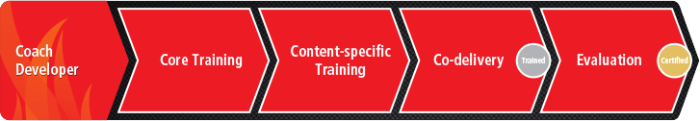

**Training:** The following training is required by all Coach Developers:

**Core Training:** Provides Coach Developers with the skills to perform their role.

Consult the CAC web site for a [summary of core training for coach developers](http://www.coach.ca/files/Summary_of_Core_Training_EN_may2016.pdf)

**Content-specific Training (sport or multi-sport):** This includes micro-facilitation which gives Coach Developers an opportunity to practise delivery with their peers.

**Co-delivery:** This is a chance for the new Coach Developer to practise with real coaches alongside an experienced Coach Developer.

Once a Coach Developer has all of the above training pieces they are considered “TRAINED”.

**Evaluation:** Evaluation confirms that the Coach Developer is capable of certain abilities which are deemed important in the training of coaches.

Once a Coach Developer has been evaluated they are considered: “CERTIFIED”.

For more information please visit:

NCCP: <http://www.coach.ca/coach-developer-training-s16933>.

## Identification and Selection of Coach Developers

Master Coach Developers (MCDs), PTSOs, and ACA can identify Coach Developer candidates.

ACA balances the regional training requirements with the need to have appropriate representation of all regions in Canada. Many candidates are coaches who are already involved in the NCCP and may have backgrounds in physical education, kinesiology, or similar areas of study. The competencies of the Coach Developers are clearly indicated in the evaluation tools.

## Learning Facilitator

Every NCCP and Alpine workshop is led by a trained Learning Facilitator (LF) who has undergone a standardized training process. LFs are crucial to the development of skilled, knowledgeable coaches who are then able to develop safer, happier athletes/participants.

The goal of an LF is to effectively facilitate sessions that result in the development of coaches who can demonstrate their abilities and meet the standards established for certification. An LF should have the appropriate knowledge, skills, and attitudes to facilitate workshops using the competency-based approach. In addition, they serve as contributing members of the community and ambassadors for the Alpine and the NCCP.

### How to Become a Learning Facilitator?

All Learning Facilitators complete the following steps:

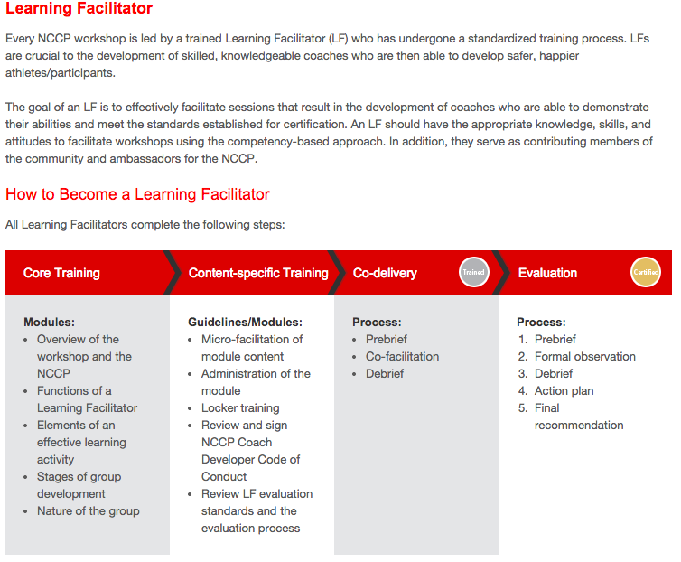

For more information please visit:

NCCP: <http://www.coach.ca/learning-facilitator-p156718>.

ALPINE: <http://www.canskicoach.org/en/certification-programs/mentors-evaluators-facilitators>

### Selecting Learning Facilitators

The success of Alpine and NCCP training rests to a large degree on the quality of the individuals selected as Learning Facilitators.

Selection of applicants for LF training and designation shall be made in consultation with the P/TCR representative

It is recommended that Alpine Learning Facilitators are:

Good communicators: can speak clearly and communicate professionally;

Good presenters: are comfortable presenting in front of a group, are well spoken, can keep presentations to time limits, and able to adapt to questions and changes;

Good facilitators: can facilitate discussions, actively listen, evoke participation, and move discussions along when need be;

Good organizers: are well prepared, organized, and professional;

Good technical experts: have good knowledgeable of technical/tactical ski racing concepts

Also: approachable, ethical, responsible, and self-confident.

**Qualifications**

For more information on specific qualifications for alpine course facilitators, consult the relevant ACA policy guidelines.

### Core Training

Core Training for Learning Facilitators is a mandatory component of training for Learning Facilitators. It is recommended that Core Training is completed prior to coming to Content-specific Training.

Core Training can be accessed through the P/TCR in each province or territory.

### Alpine Content-specific Training

Content-specific Training is a mandatory component of training for Learning Facilitators. Content-specific Training will include a micro-facilitation component of the content that will be delivered.

All Coach Developers must sign the *NCCP Coach Developer Code of Conduct* or the Alpine equivalent, during Content-specific Training.

Content-specific Training will also include 1-2 days of training, depending on the Alpine course, to prepare Learning Facilitators for the course content they will deliver.

ACA provides content-specific training for Learning Facilitator.

For more information on content-specific training for Learning Facilitators, [consult the web site](http://www.canskicoach.org/en/certification-programs/mentors-evaluators-facilitators).

### Co-delivery

All Learning Facilitators must co-facilitate a workshop with an experienced Coach Developer prior to facilitating a workshop on their own.

Co-facilitation should occur within 2 months of Content-specific Training.

Co-facilitation is part of training and therefore the Learning Facilitator candidate being trained will not be paid.

A Learning Facilitator candidate may be required to co-facilitate a workshop a number of times before facilitating a workshop on their own.

### Evaluation

All Learning Facilitators must be evaluated to become certified Learning Facilitators.

Learning Facilitators should be evaluated within 12 months of co-facilitation.

Learning Facilitators will be evaluated in person.

Learning Facilitators will be evaluated against the CAC Learning Facilitator Outcomes, Criteria, and Evidence of Achievement.

All Learning Facilitators must complete the Make Ethical Decisions online evaluation.

### Professional Development and Licensing

All Learning Facilitators are required to be “licensed” annually according to the [ACA Policy for Ongoing Education and Licensing](http://www.canskicoach.org/documents/policies/ACA_CSCF_Coach_Licensing_policy_long_en.pdf)

All Learning Facilitators must complete the NCCP MED on line evaluation in the context in which they are facilitating.

### Honorarium

Fees schedules, per diems and mileage rates are set by ACA and PTSOs.

## Coach Evaluator

A Coach Evaluator’s role is to contribute to the development of coaches after they have acquired their NCCP training. This includes assessment, evaluation, debriefing, and follow-up with coaches trying to achieve Certified status. Coach Evaluators are experts in the observation process and have in-depth knowledge of the outcomes, criteria, and evidence that comprise the evaluation tools that establish NCCP standards for coaches of a particular sport context.

Coach Evaluators act as a resource to coaches seeking to augment and validate their coaching abilities.

### How to Become a Coach Evaluator?

All Coach Evaluators complete the following steps:

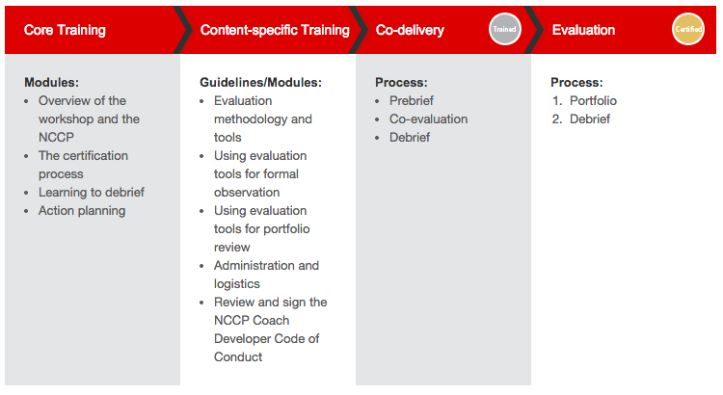

For more information, please visit:

NCCP: <http://www.coach.ca/coach-evaluator-p156721>.

ALPINE: <http://www.canskicoach.org/en/certification-programs/evaluator>

### Selecting Coach Evaluators

The success of any evaluation program rests to a large degree on the quality of the individuals selected as Coach Evaluators. It is critical that quality control be exerted when appointing someone as a Coach Evaluator, as not everyone possesses the experience, skills, or attitudes to be effective in this position.

Applicants for Coach Evaluator training and designation will be selected in consultation between ACA and the appropriate PTSO.

It is recommended that Coach Evaluators have:

a minimum of 3 years of coaching experience in the context in which evaluation takes place;

successfully completed the NCCP Make Ethical Decisions on line evaluation requirements;

credibility with their peers;

high ethical standards and leadership skills;

a desire to see the coach certification system as well as the sport grow;

time and energy to commit to the evaluation process;

proven guiding and facilitation skills;

the ability to be critically reflective and ask questions

the ability to listen actively to the candidate.

Although desirable, it is not critical that the Coach Evaluator have a higher position and significantly greater coaching experience than the candidate.

It is also recommended that Coach Evaluators have the following Alpine experience, background, and abilities:

Possess a thorough understanding of the ACA Evaluator Guidelines document in the relevant context

Have completed all context relevant training as an Evaluator as described in the NCCP coach evaluator pathway

Have completed a yearly update to maintain active status

### Core Training

Core Training for Coach Evaluators is a mandatory component of training for Coach Evaluators. It is recommended that Core Training is completed prior to coming to Content-specific Training.

Core Training can be accessed through the P/TCR in each province or territory.

### Content-specific Training

Content-specific Training is a mandatory component of training for Coach Evaluators. Content-specific Training will include a micro-evaluation component, using sport-specific evaluation tools.

All Coach Developers must sign the *NCCP Coach Developer Code of Conduct* or Alpine equivalent, during Content-specific Training.

Content-specific Training will also include:

Content-specific Training is a 1 day training to prepare Coach Evaluators for the tools they will use in evaluation.

Both ACA and PTSOs provide content-specific training for Evaluators.

For more information on content-specific training for Evaluators, [consult the web site](http://www.canskicoach.org/en/certification-programs/evaluator).

### Co-delivery

All Coach Evaluators must co-evaluate with an experienced Coach Developer prior to performing an evaluation on their own.

Co-evaluation should occur within 2 months of Content-specific Training.

Co-evaluation is part of training and therefore the person being trained will not be paid.

A Coach Evaluator candidate may be required to perform co-evaluation a number of times before performing an evaluation on their own.

### Evaluation

All Coach Evaluators must be evaluated to become a certified Coach Evaluator.

Coach Evaluators should be evaluated at least every 5 years.

* All Coach Evaluators must complete the NCCP Make Ethical Decisions online evaluation relevant to the context in which they are evaluating.

### Professional Developing and Licensing

* All Evaluators are required to be “licensed” annually according to the [ACA Policy for Ongoing Education and Licensing](http://www.canskicoach.org/documents/policies/ACA_CSCF_Coach_Licensing_policy_long_en.pdf).

## Master Coach Developer

The role of the Master Coach Developer (MCD) is to train, to evaluate, to support, and to mentor Coach Developers, i.e. Learning Facilitators (LFs), Coach Evaluators (CEs), and other MCDs. In addition, MCDs play a key role in promoting the NCCP.

Master Coach Developers must possess adequate knowledge and expertise in facilitation to assist in training Coach Developers and to lead workshops and professional development experiences for Coach Developers.

It is expected that Master Coach Developers will have more responsibility in a supportive role with Coach Developers during workshops, evaluations, and in Coach Developer development. MCDs should be willing and able to lend support to Coach Developers, program administrators, and delivery host agencies.

### How to Become a Master Coach Developer

All Master Coach Developers complete the following steps:

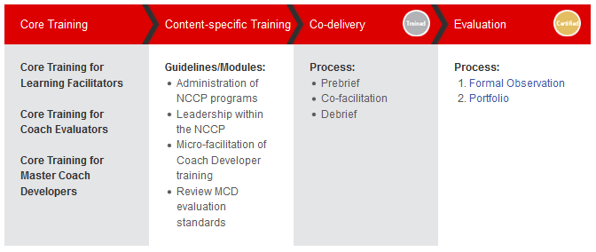

For more information please visit: <http://www.coach.ca/master-coach-developer-p156720>.

### Selecting Master Coach Developers

Applications for MLF training and designation shall be made to the ACA Director Sport Domestic. Applicants will be selected in consultation with the appropriate PTSOs.

MCDs must possess the following:

have five years of experience or more as an LF;

have successfully completed the NCCP Make Ethical Decisions online evaluation;

are trained or educated in an area related to coaching or coach education;

have relevant coaching experience in Alpine ski.

The duties of an MCD include:

helping with selection of the LFs and Es

training of the LFs and Es

evaluation of the LFs and Es

mentoring of the LFs and Es

It is recommended that Master Coach Developers have the following sport-specific experience, background, and abilities:

Expert technical and tactical knowledge of ski racing

Knowledge and understanding in the NCCP coach developer pathway

Contextual understanding and knowledge in athlete skill development and growth and development

Experienced in training and instructional methods in an adult education environment

Successful completion of the NCCP Making Ethical Decisions on line evaluation

Successful completion of the MCD training sessions

Demonstrable skill in the NCCP core competencies: leading, valuing, interacting, problem solving, critical thinking

Must be have completed all NCCP requirements in the Coach Developer pathway

### Core Training

Core Training for Master Learning Facilitators is a mandatory component of training. It is highly recommended that Master Learning Facilitators also take Core Training for Learning Facilitators and Core Training for Coach Evaluators.

It is recommended that all Core Training is completed prior to coming to Content-specific Training.

Core Training can be accessed through the P/TCR in each province or territory.

### Content-specific Training

Content-specific Training is a mandatory component of training for Master Coach Developers. Content-specific Training will include a micro-facilitation component of the content that will be delivered.

All Coach Developers must sign the *NCCP Coach Developer Code of Conduct* or the Alpine equivalent, during Content-specific Training.

Content-specific Training will also include:

Content-specific Training is a 2-3 day training to prepare Master Coach Developers for the content they will deliver.

For more information about MCD training and certification, contact the Alpine Canada domestic department.

### Co-delivery

All Master Learning Facilitators must co-facilitate LF training with an experienced Coach Developer prior to facilitating training on their own.

Co-facilitation should occur within 2 months of Content-specific Training.

Co-facilitation is part of training and therefore the person being trained will not be paid.

A Master Coach Developer candidate may be required to co-facilitate training a number of times before facilitating training on their own.

### Evaluation

All Master Coach Developers must be evaluated to become certified Master Coach Developers.

All Master Coach Developers should be evaluated at least every 5 years

All Master Coach Developers must complete the NCCP Make Ethical Decisions online evaluation.

All Master Coach Developers shall attend in person training every (3) years

All Master Coach Developers shall attend a yearly update to maintain MLF status

### Professional Development and Licensing

All Master Coach Developers are required to be “licensed” annually according to the [ACA Policy for Ongoing Education and Licensing](http://www.canskicoach.org/documents/policies/ACA_CSCF_Coach_Licensing_policy_long_en.pdf).

Business Model

## Communication

### Inclusivity, Accessibility, and Official Languages

All components of the NCCP are accessible to and inclusive of: any gender, visible minorities, the aboriginal community, and of persons with a disability. The language and content should be appropriate for the varied target groups. In addition, all materials for each context must be launched simultaneously in both official languages, following final approval.

### Copyright

The CAC holds co-copyright with ACA on all materials produced by ACA with CAC financial support. The principles of this agreement are as follows:

* ACA must ensure to provide all copyright warnings for the user;
* ACA must include and use the approved NCCP recognition guidelines. The CAC will provide ACA with the materials in electronic format (or camera-ready artwork) in both official languages, for incorporation into ACA materials;
* World co-copyright is held jointly by ACA and the CAC with a corresponding credit line to ACA;
* ACA may distribute and sell non-integrated materials as it sees fit and will retain 100% of any income it receives from its own sale of materials. The sale of integrated materials will be governed by stipulations in the memorandum of agreement signed by the CAC and ACA;
* The CAC may, at its discretion, use the materials in composite products related to coach education.

### Identification and Credit

All NCCP materials produced require the following:

* Use of the coach.ca and NCCP logos on the title page or screen of all NCCP materials;
* Proper credit given to the Government of Canada;
* Clear acknowledgment of ACA and CAC co-copyright for materials developed with CAC financial support, and sole ACA copyright for materials developed without CAC financial support;
* Use of the phrase “Printed in Canada” on all printed materials;
* Materials from other sources be properly credited;
* Version number and production date.

The following statement must appear in the credits:

*“The National Coaching Certification Program is a collaborative program of the Government of Canada, the provincial/territorial governments, the national/provincial/territorial sport organizations, and the Coaching Association of Canada.”*

To access a template that includes these statements, contact the Alpine NCCP coaching consultant

The following statement must appear in the Coach Resources (workbooks):

**The Collection, Use, and Disclosure of Personal Information**

*“The Coaching Association of Canada collects your NCCP qualifications and personal information and shares it with all NCCP partners according to the privacy policy detailed at www.coach.ca. By participating in the NCCP you are providing consent for your information to be gathered and shared as detailed in the privacy policy. If you have any questions or would like to abstain from participating in the NCCP please contact* [*coach@coach.ca*](mailto:coach@coach.ca)*.”*

CAC permissions must be obtained for re-printed materials including content, photos, and illustrations.

## Responsibilities and Planning

### Alpine Canada Alpine

ACA is responsible for:

* planning, scheduling, staffing and delivering Development Level, and Performance Level pathway events across the country
* planning, scheduling, staffing and delivering coach professional development events across the country as it sees fit.

### Provincial/Territorial Sport Organizations (PTSOs)

PTSOs are responsible for:

* planning, scheduling, staffing and delivering Entry Level courses in their respective provinces
* planning, scheduling, staffing and delivering any other coach certification pathway events that the are available for delivery by PTSOs as agreed with ACA.
* planning, scheduling, staffing and delivering coach professional development events in their respective province that they deem beneficial for coaches.

### Alpine Clubs and Regional Bodies Belonging to PTSOs

Clubs and regional bodies belonging to PTSOs are responsible for:

* planning, scheduling, staffing and delivering coach professional development events in their respective province that they deem beneficial for coaches
* planning, scheduling, staffing and delivering any other coach certification pathway events that are available for delivery by clubs as agreed with ACA.

### The Locker (the NCCP Database)

* ACA is responsible for the transfer of ALL coach training, certification and professional development events to the Locker. This is accomplished through the CAC sport data connector and manual entry by ACA staff directly into the Locker.
* PTSOs are responsible for scheduling and administering all pathway and professional development events in ACA-CSCF Partner Services web-based portal. ACA shall provide recognized organizations with all necessary training and account set-ups.

### Succession Planning

* ACA is responsible to staff the ACA domestic department with personnel capable of and knowledgeable in operating and administering the NCCP for Alpine Ski.

### Coach Developer Recruitment, Retention, and Recognition

* ACA selects and trains all MLFs, MEs, LFs and Es for course and evaluation delivery across the country.

## Fee Structure and Payment

### Workshop Registration Fees

* ACA sets training and evaluation event fees, generally on the basis of $125.00 per day for pathway events and $105.00 per day for PD events.
* ACA may provide incentives for early registration.
* All fees for scheduled events are displayed on the web site as all registrations are transacted on the web site.
* For coaches who transfer or cancel course registrations, ACA has a published [course refund and transfer policy](http://www.canskicoach.org/documents/policies/course_refund_transfer_policy_en.pdf).
* PTSOs set fees for Entry Level course run in their province. ACA sets an agreed on maximum Entry Level course fee.

### Coach Developer Fees

* ACA sets the fee schedule for all LFs and evaluators who run courses/evaluation for ACA directly. The fees are based on experience facilitating and/or evaluating, coach developer certification level and coaching experience in the field.
* Daily fee rates start at $225.00 per day.
* All ACA coach developers will sign an ACA contractor agreement for each season prior to delivering ACA courses.
* PTSOs set the fee schedule for LFs and evaluators who run courses/evaluations for the PTSO.

## Professional Development and Licensing

The Coaching Association of Canada and its partners recognize the value of having certified NCCP coaches that are engaged in professional development programs which reinforce the values of lifelong learning and sharing amongst the coaching community.

In order for Alpine coaches to maintain their certified status, they will be required to obtain professional development credits. PD points can be earned through a multitude of activities that coaches already participate in, including: national and provincial sport organization conferences and workshops, eLearning modules, NCCP workshops, coach mentorship programs, and active coaching. In most cases coaches are already earning their required PD points – Maintenance of Certification Status is simply the introduction of tracking these points and recognizing coaches for their efforts.

Maintenance of certification is essential to:

* ensuring coaches stay current with new coaching practices and knowledge;
* maintaining the integrity of the NCCP;
* maintaining consistency with the standards of other professions;
* reinforcing the values of lifelong learning and continuous improvement.

Certification within the NCCP shall be valid for a maximum period. The concept of “life-span of NCCP certification” shall apply to coaches who:

* Are already certified according to the standards of the Levels-NCCP.
* Are certified according to the standards of the Levels-NCCP while it is still in effect.
* Are certified according to the standards of an NCCP context’s core certification and gradations.

Maintenance of certification must be based on active coaching and professional development.

For more information please visit: <http://www.coach.ca/maintenance-of-certification-s16745>.

|  |
| --- |
| When sportifying the *NCCP Operations Manual*…   * Highlight or emphasize the PD credits required for your sport only. You may delete the columns of the years not applicable, and the contexts that are not applicable. * Include any additional requirements for maintenance of certification. * Delete this box when you have finished sportifying the *NCCP Operations Manual*. |

## Quality Control

### Course Evaluation

ACA will conduct an annual quality review of the coach education program. This review shall consider the following:

* All course participants are provided with a course evaluation forms at the end of each course. Course evaluations forms are sent to ACA by LFs and reviewed by ACA Domestic staff on a regular basis, course by course.
* Course evaluations influence LF hiring and regional LF training the following season.
* Recommendations based on course evaluations to be made in consultation with the PTSOs upon review of the course evaluation results

### Program Monitoring, Delivery and Evaluation

It is the responsibility of ACA in partnership with the PTSOs to:

* Maintain an appropriate number of MLFs, MEs, LFs and Es available for program delivery and evaluation
* Provide an appropriate number of opportunities for LFs to facilitate courses
* Partner with PTSOs to ensure appropriate number of opportunities for evaluations
* Appropriate number of opportunities will depend largely on the number of accredited LFs and Evaluators available
* Review the performance of LFs or Evaluators receiving unfavourable evaluations
* Develop actions plans to assist LFs or Evaluators with additional training if required
* Consider removing LFs or Es if further training is not productive
* Review annually the roster of active MLFs, MEs, LFs and Es to determine future training requirements
* Review annually logistical PTSO reports regarding; numbers of licensing events, numbers of coaches participating, numbers of coaches certified in various contexts, numbers of evaluations
* Monitor requirements for training and development of coach education personnel to meet the linguistic and geographical profiles of the PTSOs

### Revision and Update Cycle

ACA adheres to the principle of Best Practises. To that end ACA will review on an ongoing basis:

* Course candidate resource materials and workbooks updated annually by ACA
* Update and improve course content to ensure such content is in line with current NCCP material

## Minimum Age Restrictions

* All coaches participating in any NCCP recognized training evaluation event must be 15 years of age on the first day of the training or evaluation event.
* No exceptions.

# Tools

## NCCP Code of Ethics



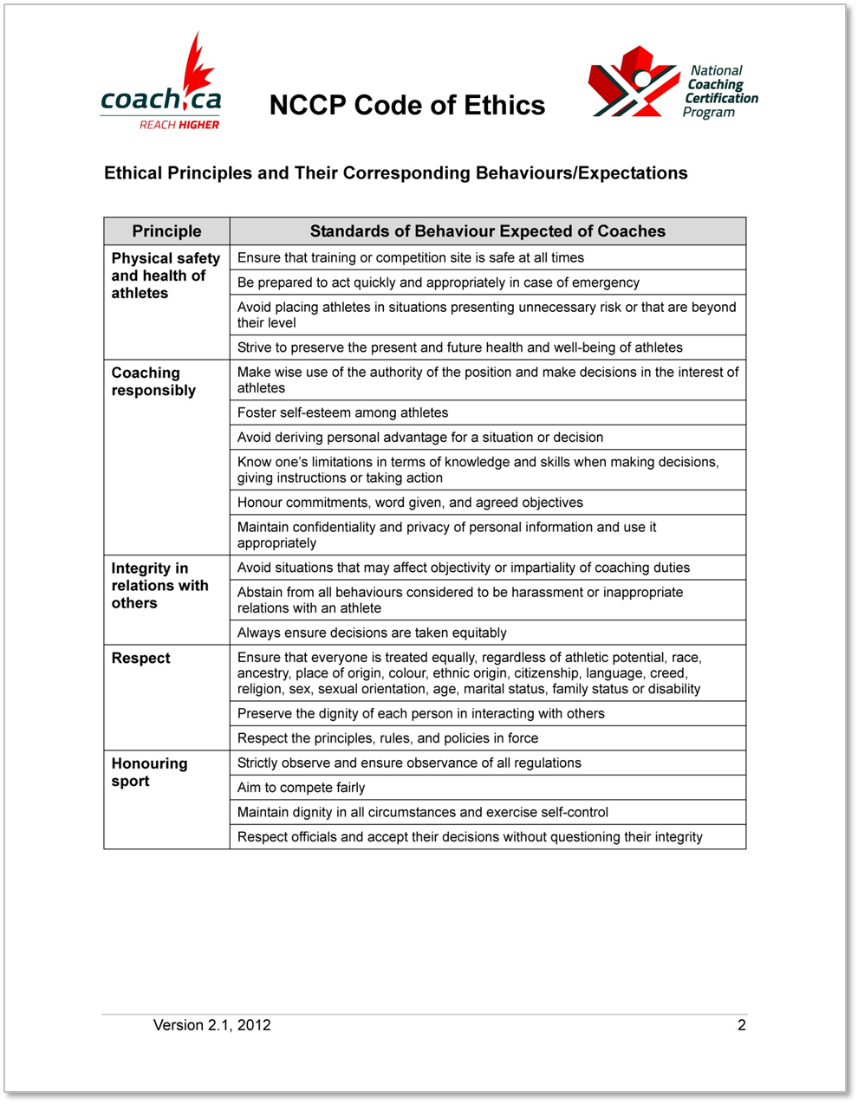

## Alpine Coach Developer Code of Conduct

It is expected that every Coach Developer will read, understand, and sign this Code of Conduct.

***Preamble***

In my role as a Coach Developer in the National Coaching Certification Program (NCCP) for Alpine Canada Alpin, I, ________________________________ expressly agree to conduct myself in a manner consistent with this Code of Conduct.

I understand that my failure to abide by this Code of Conduct can result in sanctions being imposed, including the revocation of my Coach Developer certification status.

The following Code of Conduct shall apply:

**Code**

The individual shall:

1. Support key personnel and systems of Alpine Canada Alpin (ACA) and partner organizations in a positive and professional manner at all times, while on course and working in the field.

2. Provide the most up-to-date instruction and coaching possible.

3. Make every effort to attend professional development sessions annually, to improve personal abilities and performance.

4. Align with the common goals and objectives of the ACA and partners as they service the membership at large.

5. Avoid discrediting specific ski equipment, manufacturers, sponsors, suppliers, employer and/or other Industry partners.

6. Exhibit exemplary professional behavior at ski areas.

*Courtesies are often accorded at ski areas that should be considered a privilege and not a right.*

7. Approach problems and issues (technical and non-technical) in a professional and respectful manner seeking solutions that support due process.

**Responsibility**

If there is disagreement or misalignment on issues, *it is the responsibility of the individual staff or facilitator/evaluator* to seek alignment with the objectives, goals and directives of ACA.

Please, be advised that the CSCF Board ACA management will take necessary disciplinary action should any material breach of this Code occur.

_________________________ _________________________ _____________

Name (please print) Signature Date

